
Call for Papers and Posters:
The Third Annual Missouri Egyptological Symposium

Dear Colleagues,

We are excited to announce our Call for Papers and Posters for the Third Annual Missouri Egyptological Symposium, which will take place at Missouri S&T in Rolla, Missouri on October 30, 2021, and is co-sponsored by the American Research Center in Egypt, Missouri Chapter. Whether or not you are from Missouri or currently reside in Missouri, you are invited to share your research with our Missouri community of Egyptologists and students of ancient history.

We welcome abstracts from academics, museum professionals, independent scholars, and students at all stages in their careers for in person or virtual papers or posters. Papers will be 15 minutes, followed by 5 minutes of questions. Abstracts should be no longer than 300 words and must be submitted by September 3, 11:59pm CST. Space is limited, and as such abstracts will be vetted. Please submit here: https://forms.gle/YskdmDcgryGtiR2f6.

The first Missouri Egyptological Symposium was organized by Sara Orel at Truman State University in 2018, and was born out of a shared desire to bring together Egyptologists in the Ozarks and surrounding areas. The second symposium was organized by Julia Troche at Missouri State University in 2019, and focused on Interconnections, broadly defined, and included an educators’ workshop. Talks at the first two symposia covered topics as broad as Middle Kingdom co-regency, Egypt, Illinois, the cults of Serapis and Osiris in the Roman Empire, the archaeology of a Coptic monastery, the Exodus in Jewish memory, letters from 19th century archaeologists, tattooing, and Magic Lantern slides. We hope to continue this trend of bringing together diverse, innovative, and unique research on a wide range of topics relating to ancient Egypt, from its prehistory through the Islamic Period, inclusive of Egyptomania studies, and studies of modern histories and technologies of archaeology in Egypt and conservation of ancient Egyptian remains.

The Third Missouri Egyptological Symposium does not have a specific theme, but is driven by goals of inclusivity and opportunity. To this end, we are particularly eager to hear from MA and PhD students who may be looking for a supportive space to present new work. If you want to create a poster, but are not able to attend in person we will still be able to post it at the symposium, and are also trying to make arrangements for you to still receive feedback on your poster research. The symposium, and all papers/posters, will take place on Saturday October 30, but related events will also take place on Friday October 29.

We look forward to reading your abstracts,
The Organizing Committee
#MOEgypt3

Contact with questions:

Kathleen Sheppard (sheppardka@mst.edu)
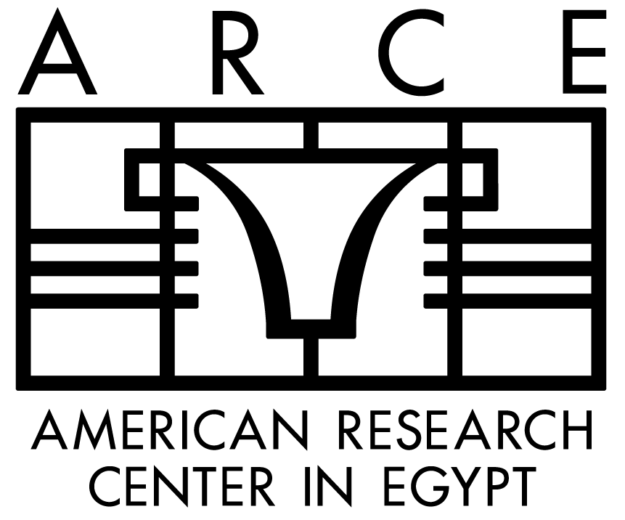
Julia Troche (JuliaTroche@MissouriState.edu)
